**ASSIGNMENT-10.2**

● Create a database named 'custom'.

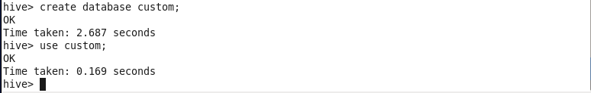

● Create a table named temperature_data inside custom database

Creating table

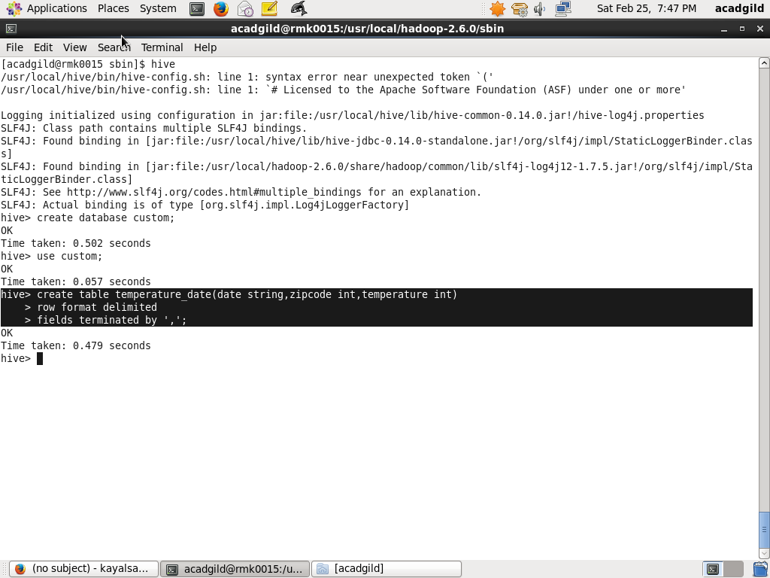

● Load the dataset.txt (which is ',' delimited) in the table.

Loading the data

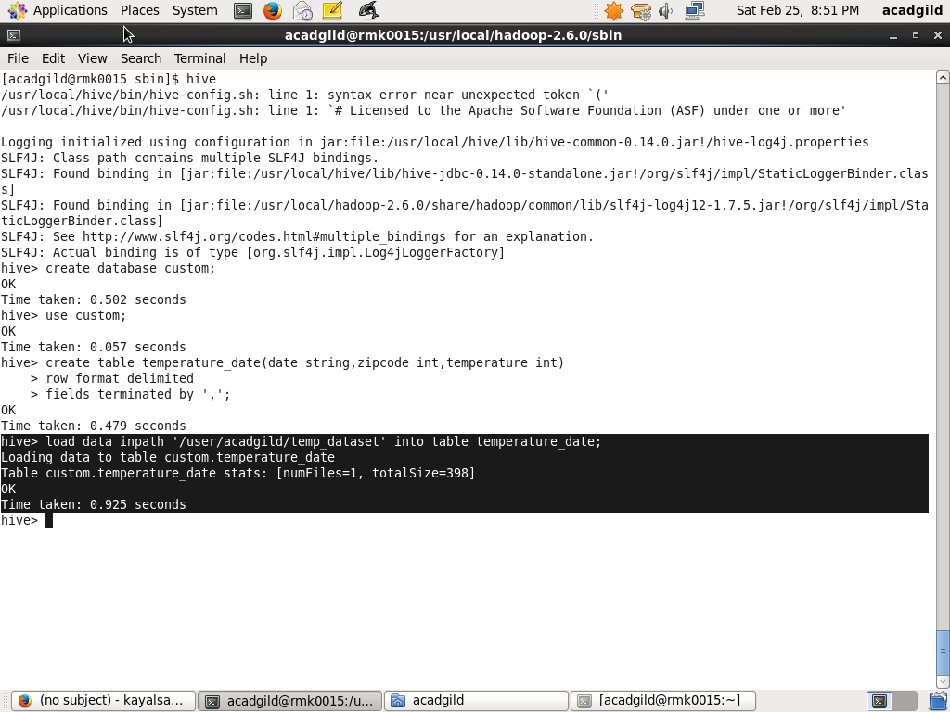

* Displaying the result

